[1]

HEAR, HERE; Sign language translator

-We communicate with you-

2016026280 Baek Seungjeong 2016026217 Kim Hyeonwoo 2016026335 Yang Chaeeun 2017053709 Rany Punreach

Hanyang University Hanyang University Hanyang University Hanyang University

Dept. of Information system Dept. of Information system Dept. of Information system Dept. of Information system

Seoul, Korea Seoul, Korea Seoul, Korea Seoul, Korea

bsj119kr@naver.com zxc_3434@naver.com dmdksl417@daum.net punreach.rany@yahoo.com

*Abstract*— More than 100 million deaf people around the world communicate in sign language. Sign language provides relatively accurate and abundant means of communication to deaf people and people around them, but it is still impossible to communicate with people who do not know sign language. In order to facilitate communication between signers and non-users, sign language interpreters using machine learning are provided. Sign language motion will be output by voice after recognition, voice will be recognized and printed by video of sign language motion and will make communication more convenient for deaf people. In addition, it will help globalize sign language users by interpreting the sign language motion of people from different languages who cannot communicate with each other due to different sign language movements.

*Role Assignments*

|  |  |  |
| --- | --- | --- |
| Roles | Name | Task description and etc. |
| User/  Customer | Baek Seungjeong | Sign language users from various languages are chosen as the main customers. Through newspaper articles and Internet materials, we get basic information about major sign language behaviors. And find and acquire open sources for sign language spoken by a large population, such as English and Spanish. Korean sign language learns machine learning by directly operating major movements. The more data you collect, the more accurate the translation is possible, so try to build as much data as possible. |
| Software developer | Kim Hyeonwoo | Software developer thinks about the software system in general. He analyzes, categorizes the related software and examines the software that can be used to implement the application. He will investigate about what development tool we will use to implement. |
| Software developer | Rany Punreach | In addition to checking overall aspects of software development, he also focuses on application development. With checking and developing basic application operations, relevant data are collected and applied to create user-friendly applications. Continuing to accommodate users' opinions is also required. |
| Development manager | Yang Chaeeun | Development manager should confirm if the functions of software fullfill users’ need. When they do not satisfy users, she gathers some information from users and customers. Then, she advises software developer to update it and mediate both of them. |

# INTRODUCTION

*Motivation*

S

ign language is a language that enables visual communication without the use of words and is continuously recreated by deaf people. The language people hear is the auditory speech language system, while sign language is the visual motor system. Sign language is identified by the eye but not by the ear, and disappears as soon as it is recognized as a language. Sign language for many hearing-impaired schools in Korea is being implemented within the curriculum, as are other schools. Sign language is a means for deaf people to live as socialites by taking advantage of their own characteristics.

Sign language, however, does not solve all the discomforts of deaf people. Those who use sign language are only those who are deaf or directly related to deaf people such as family members, teachers and interpreters. Few people can communicate in sign language. In this situation, signers and non-signers need the help of handwriting or translators to communicate with each other. Because this is not a direct way of talking, there is no clear delivery of information or emotions, and there is also a lot of time and money to be invested. People with hearing impairments such as purchases of goods, visits to government offices and banks are not easy to stand on their own feet because they have to communicate countless times with people who don't sign language in their daily lives. In particular, for professional activities, only limited tasks are handled by very limited groups.

An immediate and easy-to-understand system or technology between signers and non-users is essential in order to give hearing-impaired people wider opportunities for communication and to provide independence and convenience in many areas of daily life. Currently, many companies and engineers are struggling to introduce and commercialize these technologies. Despite these attempts, market entry is still not taking place, and almost all attempts are centered on ASL.

Against this backdrop, we want to develop a Korean sign language translation system for more than 300,000 deaf people in Korea. Korean signers and non-users will be able to communicate through simple mobile phone applications without the help of professional interpreters.

In addition, we would like to provide translations between sign language gestures used in various languages based on the translation between Korean and English sign language. If interpretation services are provided for sign language movements in various countries, it will be possible to do international activities of very limited deaf people so far, and their independence on the global stage will also be possible.

First, we need artificial intelligence technology to recognize sign language behavior in various languages. OpenCV is one of the open source computer vision libraries, which focus on cross-platform and real-time image processing. When image recognition is carried out through it, it is stored on an external server and connected. Applications that imply camera function can take video and pictures of motion and translate them into text language or voice language. Conversely, it is also possible to show images within the application by switching the text or voice language of people who do not use sign language into motion.

We hope that local deaf people will be able to improve their quality of life and make inroads into the wider world through this system.

*Problem statement (client’s needs)*

- There are 100 million deaf people around the world communicating in sign language and more than 300,000 deaf people in Korea.

- In order to communicate with non-users, sign language users need the help of a professional interpreter, which is very expensive.

- Technologies related to sign language interpreters are emerging, but this is ASL-centric, and has not yet been commercialized.

- Since there is no technology yet to translate sign language within different languages, it is almost impossible for deaf people to communicate in sign language with foreigners.

- Convenient dialogue with the non-disabled and foreigners is essential for hearing-impaired people to be able to participate in their daily lives or professional activities.

*Research on any related software*

## Vision-based sign language translation device

It presents a mobile VISION-BASED SIGN LANGUAGE TRANSLATION DEVICE for automatic translation of Indian sign language into speech in English to assist the hearing and/or speech impaired people to communicate with hearing people. The proposed system is an interactive application program developed using LABVIEW software and incorporated into a mobile phone. This is able to recognize one handed sign representations of alphabets (A-Z) and numbers (0-9).The results are found to be highly consistent, reproducible, with fairly high precision and accuracy.

## Sign Language Recognition with the Kinect Sensor Based on Conditional Random Fields

Sign language is a visual language used by deaf people. One difficulty of sign language recognition is that sign instances of vary in both motion and shape in three-dimensional (3D) space. In this research, we use 3D depth information from hand motions, generated from Microsoft’s Kinect sensor and apply a hierarchical conditional random field (CRF) that recognizes hand signs from the hand motions. The proposed method uses a hierarchical CRF to detect candidate segments of signs using hand motions, and then a BoostMap embedding method to verify the hand shapes of the segmented signs.

## StoryGAN : A Sequential Conditional GAN for Story Visualization

Introduce the paper published in the IEEE Conference on Computer Vision and Pattern Recognition (CVPR). We have proposed a new task called Story Visualization, which extracts major sentences from the Story and produces images corresponding to each sentence, and we propose a model called StoryGAN to study them. It is composed of various models, including Story Encoder, Context Encoder, Image Discriminator, and Story Discriminator. It suggests a method based on a Sequential Conditional GAN.

## Development of AI Sign Language Recognition Technology for the First Time in Korea

On September 11, 2018, KETI is said to have developed South Korea's first AI technology-based sign recognition technology through the government's 'Automagnetic Intelligence Digital Partner' project. AI understands sentence structure based on machine learning technology, and then extracts characteristics from users' hands, faces, and mouths and interprets them as sentences.

## SignAll

In the case of Hungarian startup "SignAll," the company has drawn much attention in the global market by developing sign recognition gloves with three cameras built in and launching a platform to translate U.S. sign language ASL.

## Amazon Alexa

Alexa has a system that interprets sign language using Google's AI open program TensorFlow. TensorFlow code AI's machine learning application to help it run on a Web browser. When users use sign language, Google's text-to-speech software converts sign language to text, translating that word into speech. Amazon Echo responds and Alexa's voice reaction is automatically converted by the computer into text, which users can read.

## RoBoHoN

NTT Data, Sharp, and NTT Data SBC are jointly equipped with sign language translation applications using AI (Artificial Intelligence) deep-running for hearing impaired people to develop a mobile robot RoboHoN (RoBoHoN), which enables simple communication of sign language learning beginners at the current stage, and continues to support deaf people's lives with the goal of facilitating sign language interpretation in various scenes in the future.

## 3D Hand gesture recognition using a ZCam and an SVM-SMO classifier

This paper presents a complete solution for the one-hand 3D gesture recognition problem, implements a solution, and proves its reliability. The solution is complete because it focuses both on the 3D gesture recognition and on understanding the scene being presented (so the user does not need to inform the system that he or she is about to initiate a new gesture).

## Interpreting sign language with computer vision and deep learning

The first step is to capture the signs and pre-process them using different computer vision techniques. Next, comes the sign recognition and detection using several deep learning approaches like CNN and RNN. At the end of these steps, we’ll have a translated output of the message.

# REQUIREMENT ANALYSIS

## Main Page

When a user downloads the application, a screen describing a simple tutorial should be displayed first. It briefly describes the functions of the application, such as sign recognition and voice/character output, voice recognition and sign language motion image playback, and sign language interpretation between different languages. Briefly describe in order and this page may be skipped. When downloading this application, the main page is the second screen. The main screen consists of contents input like a selection of motion recognition/voice recognition, the language of use, output method, and a "translation" button.

## Sign Up

Membership requires basic information and a number field for phone number authentication and a nickname request. It consists of input screen. Log-in consists of field for inputting ID and password, searching ID or password function. Terms of use and features are available by clicking View Terms and Conditions on the Membership page. The subscription page allows user to easily sign up using only their nickname, mobile number, and password. This is to make it easier for the user to use by guiding the user to join more easily. Kakao Talk, Facebook, and Naver Log-in to download the member information to each server.

a. Mobile phone number subscription Receive name (nickname) and cell phone number input. All items must be listed as required information. Upon successful membership, a message or information screen informs user that he/she has been successfully registered.

b. Request an authorization number

1. Enter cell phone number and click the button for requesting an authentication number.

2. If the user clicks "Enter Authentication Number" and the key value is authenticated, the "Membership Success" screen will appear.

3. When the user clicks the Request Authentication Number button and send the authentication number, the button is changed into the confirmation of the authentication number and the authentication number retransmission.

4. If the user clicks the authentication number retransmission button, the authentication number will be resent.

c. Error message after clicking the member button

1. It is not activated when the item 1 is not written.

2. If the authentication number is duplicated, 3 error messages will be displayed.

3. Membership is completed only when all items are entered and the cell phone number is authenticated.

## Log-in

Log-in page has a message that is invoked when a user clicks on a page that only members can access.

a. Mobile phone number login - Membership registration must be number authentication. (Self-certification required)

b. Automatic Log-in Default value: checked (selectable)

c. Find password: Go to the password search page.

d. Sign up: Go to the member registration page.

## My Page

There is a 'My Page' screen showing the members' information. It appears only when the user logs in. The user can change the password on this page. In addition, users can set up/change items here, such as their primary sign language and deaf/non-disabled.

## Set and Start the Translation

Users can do the sign language motions or talk in voice based on input/output settings. Before entering, the screen will display the words 'Start sign language movement' and 'Start your story from now on'. When the input value is not recognized properly, there will be words like 'Please move accurately' and 'Speak more clearly'. Once the user has finished entering, the application will ask additional questions such as 'Would you interpret more?' 'Yes/No'.

## Progression the Translation

At this stage, the final translated sign language content is output. Depending on the user's choice, it can be presented as a signed video, expressed in voice or in writing. After the user has acquired the output value, they are asked whether he or she will use the translation system in addition. If 'Use' is answered, the screen switches to the previous step and receives additional input for sign language motion or voice. When 'NOT Use' is answered, a simple question mark appears on the screen and receives feedback from the user. One to five stars can be assigned a simple score for the application, and additional comments can be submitted in writing. This feedback will help us improve our application.

# DEVELOPMENT ENVIRONMENT

## Choice of Software Development Platform

We want to develop the application using Android Studio in the Windows10 OS environment. Android is the most famous mobile operating system, which has large users. Android is a mobile operating system developed by Google, based on the Linux Kernel and designed primarily for touchscreen mobile devices such as smartphones and tables. According to the chart below, we can know that market share of Android OS is about 76% and it is the most part. Also, there are lots of tutorials for guidelines of mobile applications. Our team will use Android studio (Android studio 2.3.1 version) to develop these applications. The language used is Java (Java SE 8u131), MySQL and HTML will be used if the function to be linked with web.

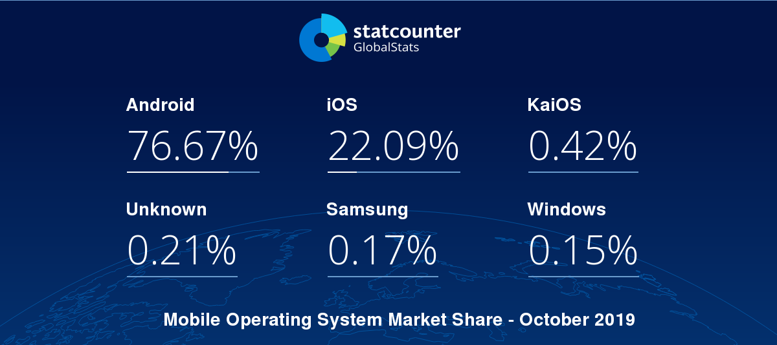

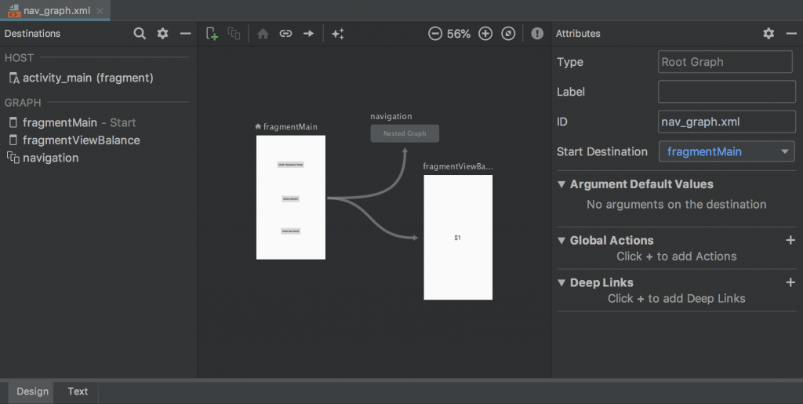

|  |  |
| --- | --- |
| Tool and Language | Reason |
| JAVA | JAVA is a general language that is concurrent, class-based, objectoriented, and specifically designed to have as few implementation dependencies as possible. JAVA is based language using in Android studio. |
| MySQL | We need to create a database where we can save information about users when they sign-up. When users try to log-in, server compares the information which they input and the information which is saved in database. To look and manage the information easily, we choose MySQL as a database management tool. |
| PHP | PHP is a programming language which is used in server. We will use PHP to develop between the server and web environment because we have learned it in another course, ‘Web system programming 2’. Therefore, we think that it will be useful for developing our server part. |
| Google push | Google push is a Technology that automatically and periodically pushes  the latest information directly to the computer screen by simply selecting the list of information that the user is interested in using the Internet environment. The push technology is a way that the server automatically provides the information that the user wants. It is an automated technology that allows users to receive specific information without having to request it every time. |

## Software in use

a. Android Studio

The IDE itself is based off the very popular IntelliJ IDEA from JetBrains and is being offered by Google for free. On the other hand, Eclipse is more mature than ever and Google's ADT plugin which transforms the popular IDE into a fully featured Android developing environment has become very stable. Instead, lots of developers want to get associated with Android application because of incredible growth. Besides, Android Studio platform developers also use Eclipse to develop applications, but always thought of Eclipse like a "StudentProject IDE (Integrated Development Environment)" and learned about it.

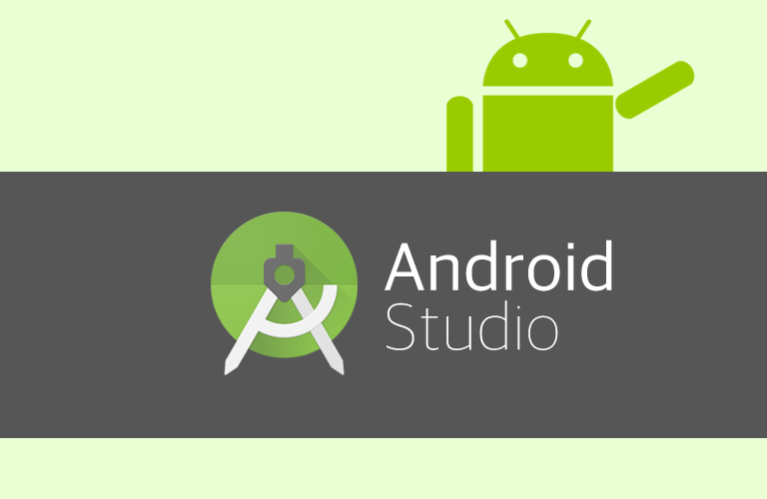

b. Realm

Database management system is software that handles the storage, retrieval, and updating of data in a computer system. Database Management System or DBMS in short refers to the technology of storing and retrieving users’ data with utmost efficiency along with appropriate security measures. This tutorial explains the basics of DBMS such as its architecture, data models, data schemas, data independence, E-R model, relation model, relational database design, and storage and file structure and much more. DBMS is a collection of inter-related data and set of programs to store & access those data in an easy and effective manner. Therefore, we are going to save information of sign languages in database.

We use Realm for our application DBMS. The [Realm Mobile Database](https://realm.io/docs/get-started/overview/#the-realm-mobile-database) is a cross-platform database solution that can be used as an alternative to [SQLite](https://www.sqlite.org/) and [Core Data](https://developer.apple.com/reference/coredata). Compared to these two options, Realm is easier to set up and use. To perform the same operation in Realm, you usually end up writing fewer lines of code than you would with SQLite or Core Data. On performance, Realm is said to be faster and it also offers other modern features such as encryption, JSON support and data change notifications.

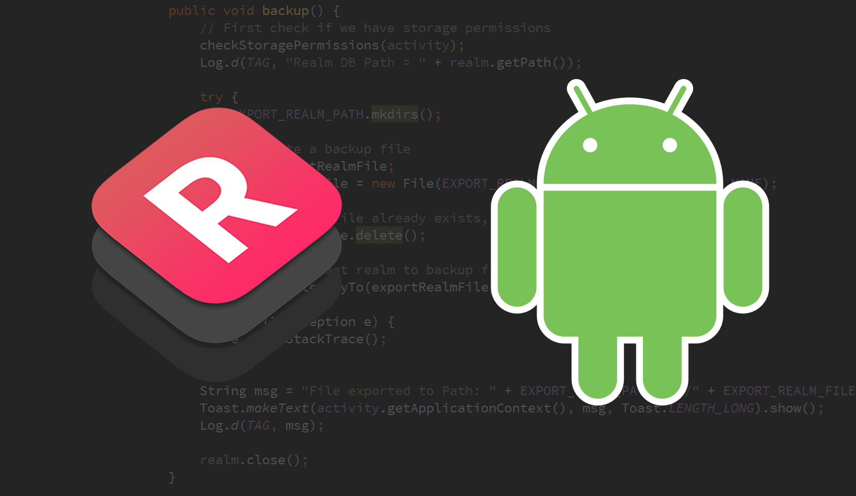

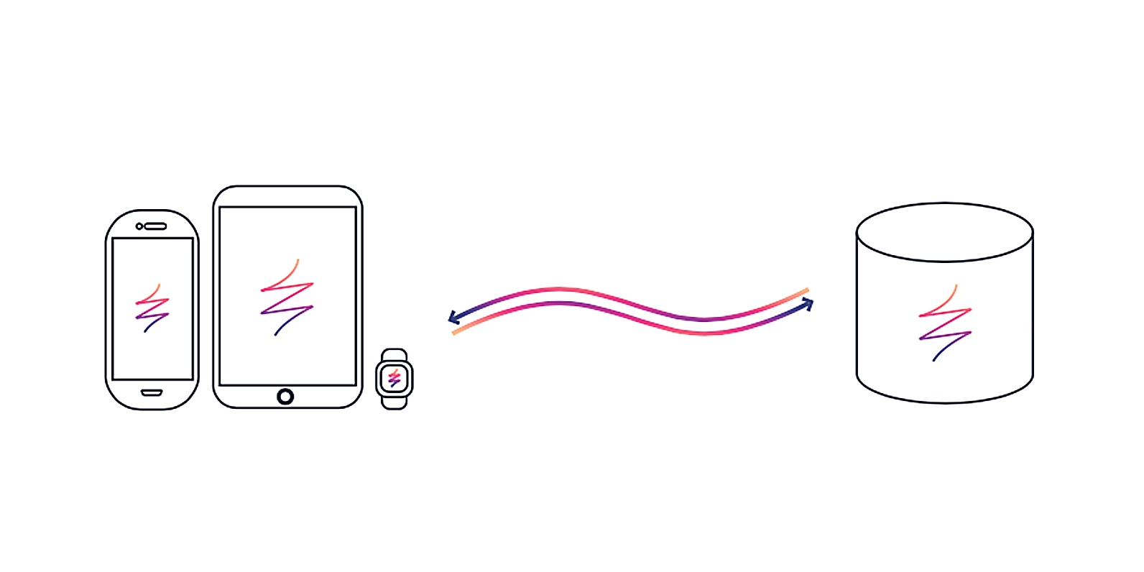

d. Google Translation API

Translation enables organizations to dynamically translate between languages using Google’s pre-trained or custom machine learning models by Google Translation API. The Basic version of the Translation API makes it possible to instantly translate texts into more than one hundred languages for your website and apps. Translation Basic API uses Google’s pre-trained neural machine translation to deliver fast, dynamic results.

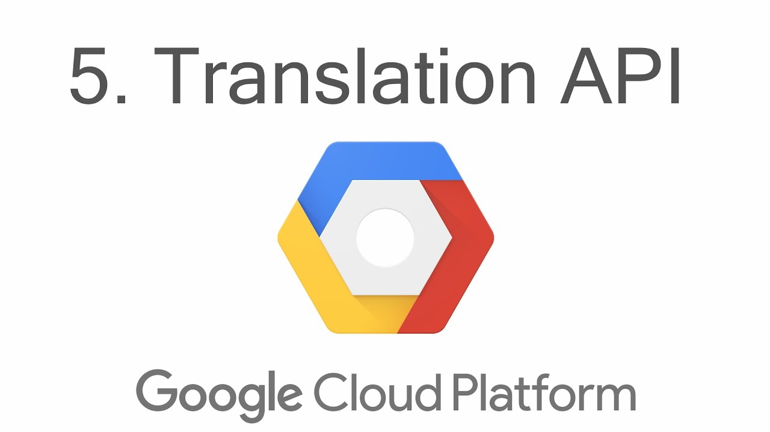

e. Git hub

GitHub is a Git repository hosting service, but it adds many of its own features. Git is a command line tool and GitHub provides a Web-based graphical interface. It also provides access control and several collaboration features, such as a wikis and basic task management tools for every project. This will help us to co-work each other and see our own code more easily. In addition, various open sources of sign language will be provided and will help us use them directly and indirectly.



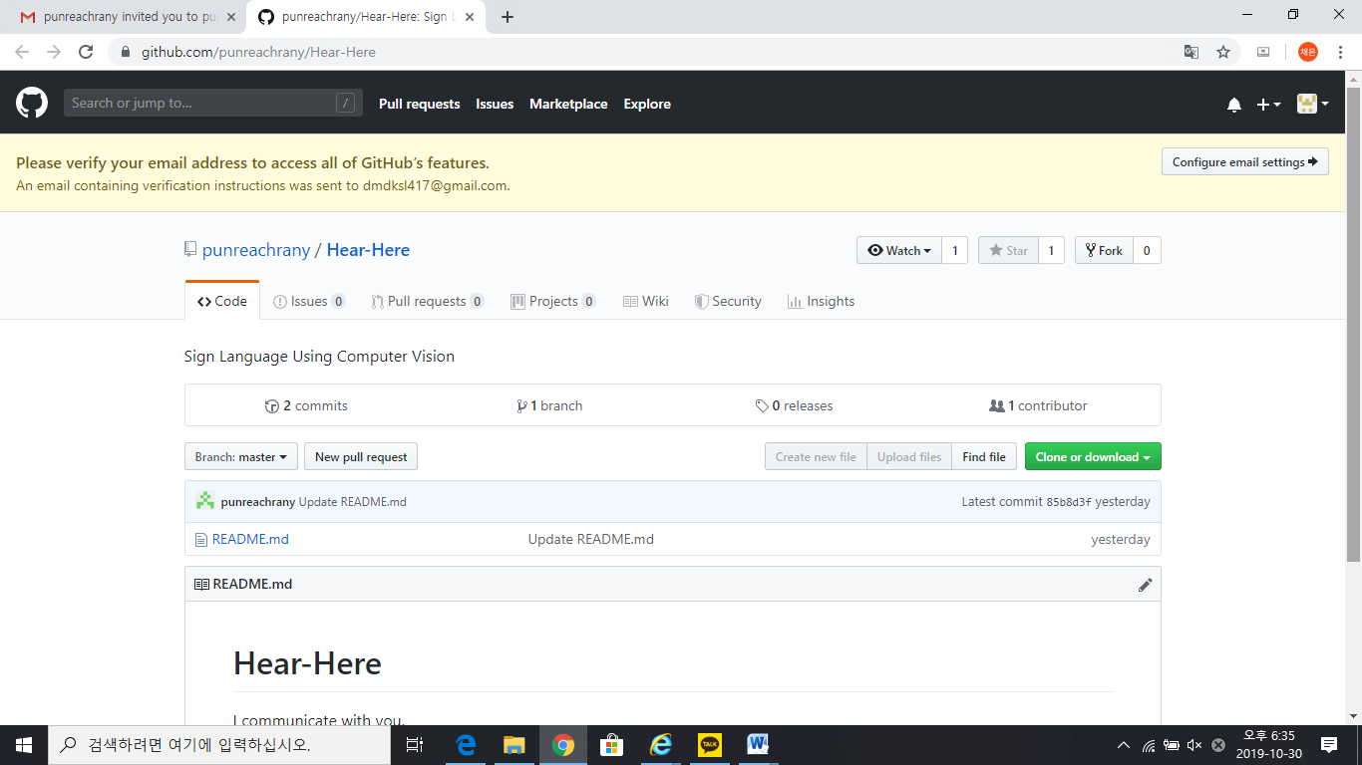

## Task distribution

|  |  |
| --- | --- |
| Name | Task |
| Baek Seungjeong | Developing sign language recognition system (Android Studio) |
| Kim Hyeonwoo | Executing open sources (Android Studio) |
| Rany Punreach | Developing Main Page, Log-in, Sign-up, My Page, etc. (Android Studio) |
| Yang Chaeeun | Connecting several sign languages server (Android Studio, Realm) |

# SPECIFICATIONS

## Main Page

Main page is the first screen when downloading this application. If user runs the application, the description of this application will be displayed on the main page first. After users read and understood this, they will see the main screen of the application. The main screen consists of contents input like a selection of motion recognition/voice recognition, the language of use, output method, and a "translation" button.

a. Tutorial of the Application (Description)

If the application is executed, the description of this application will be displayed on the main page first, and if user read it thoroughly, click the OK button and the main screen of the application will appear. The description of the application includes the following contents.

1. Usage and purpose of the application

This page is the first page that comes up when user run the app. Explain the purpose of the application to help signer language users and non-users, users in different languages, and to help the deaf people stand on their own feet.

2. Explain how to use this application

Describe how to use the application according to the order.

1) Set the output

Select the desired output.

Can choose sign language video or voice/text.

Can choose kind of sign language (We will list up available sign languages).

2) 'TRANSLATION' button

Pressing this button completes the translation.

3) ‘Sign Up’ button and ‘Log-in’ button

If the user has read this tutorial, there are a ‘Sign up’ button and a ‘Log-in’ button. The ‘Sign up’ button will go to the Sign Up page when a user who has not yet subscribed to the page clicks the ‘Sign Up’ button. If users press the ‘Log-in’ button, the existing user will go to the Log-in page to use the application.

b. Main Page

The main page consists of the menu at the top and the application name as shown. There is a 'Translation' button that starts the translation right on the main screen, and a 'History' button that allows you to view previous translation records.

1. Menu

It contains several components of the application and user can navigate to the selected page by selecting the list. The menu consists of the following items and is linked to each item.

- History

- My page

- Log-out

2. Name and logo of the application

The name of the application is ‘HEAR, HERE – We communicate with you -’, and the logo is located at the top of the application.

3. Set translation environment

### 1) Sing language user

Application users first set whether they are sign language users or non-users on this screen.

2) Input language

Application users can choose which language to sign, or voice, in which of the following lists:

- Korean

- American (English)

- Spanish

3) Output language

Application users can choose which language to sign, or voice, in which of the following lists:

- Korean

- American (English)

- Spanish

4. ‘Translation’ button

If users want to set the language, click the ' Translation' button. Pressing this button starts translation.

## Sign Up

This page appears when an existing subscribed user has moved to use this app after reading the tutorial.

a. User Authentication

The user must authenticate his or her identity in order to use the application. Users can authenticate their identity through their mobile phone number, Naver, and Facebook. Users must read the Terms of Use and select the Agree or Disagree button before authenticating their identity.

1. Authentication

Users can authenticate their identity through a mobile phone number, Naver, and Facebook login. KakaoTalk, Facebook, and Naver login to download the member information to each server.

### 1) The user enters his cell phone number and clicks the Request Authentication Number button.

2) Click "Enter Authentication Number" and if the key value is authenticated, "Authentication Verification Success" screen appears.

3) When the user click the Request Verification Number button and send the verification number, the button changes to Verification and Confirm Verification.

4) If the user click the authentication number redirection button, the authentication number will be resent. When the authentication is completed, it goes to the member registration page.

b. Sign Up

1. ID

If the user succeeds in authenticating his/her identity, the user moves to a page where he/she can register. The ID can be a combination of English and numbers, and no special characters are allowed. The maximum number of characters is 10 characters. After writing the desired ID, the user must check that his or her ID overlaps with the ID of another user. If it is duplicated, pop up screen "ID is already in use" to inform them that they need to select another ID.

2. Password

The password is a combination of English and numbers and can be up to 10 characters long. The password must be marked with asterisks on the screen when typing and the password must be entered to complete the password verification.

3. Nickname

Users can set a nickname for this application. Passwords can be up to seven characters in length, and can be in English, numbers or special characters.

4. ‘Registration’ and ‘Cancel’ button

When the user completes the subscription items and presses the registration button, the following situation occurs.

### 1) If the user correctly filled out the membership items: Users are subscribed.

2) If the user does not enter some subscription items, if the user ID or password is incorrect, or if the nickname is not entered: A popup screen will be displayed.: ‘When you are finished, go to login page.’

3) Press the Cancel button to go to the main page.

c. How to implement

Kakao Talk, Facebook, and Naver login to download the member information to each server. The app page consists of a view and the developer completes the development of the data connection operation and transferring the subscription data to the database.

|  |  |  |
| --- | --- | --- |
| Main menu | Sub menu and functions | Explanation |
| Sign Up | Terms of Use | Terms and Conditions |
| Sign Up | Phone number (ID) and password input, User Authentication mandatory, nickname |
| Log-in | Log-in screen | Log-in screen |
| Email or ID Login | Email or ID Login |
| Phone Log-in | Phone Log-in |

1. App server back-end development

Based on the ERD created in the design stage, we work on the member DB. Membership Configure a web server that communicates data to be input at the front desk and delivers it to the database server. Of course, we also work on middle servers that will deliver useful values to the database via queries.

2. App Front Development

The app page has a view that is configured and the developer completes the development of data connection work to transfer membership data to the database.

3. App development testing and Q&A (to maximize performance)

Expand all function reference definitions, ERDs, class specifications, and storyboards and perform function-specific tests to ensure that sign-up & sign-in functionality is implemented correctly. Confirm precisely whether the subscription input value is properly delivered to the database and the manager page, and whether the subscription status and subscription data appear on the server and front without missing. If there is no problem with the function-specific test, we perform the integration test whether there is a bug from the sign-up to the login. At the same time, designers and planners check carefully to see if they have a first design problem. If a bug is recorded during the inspection, or if there is a problem with the design, immediately address the problem, make a correction, or change the function.

## Log-in

a. Log-in

1. Enter ID and password

The user must enter his / her ID and password in the ID and password fields for Log-in, respectively. Automatic Log-in is selectable and is selected by default.

2. Log-in button

### 1) If the user's ID and password are established: Approved

2) If the user's ID and password are not established: Pop up screen indicating that login failed

3) If the login is successful: the main page appears

3. Find username and password

If the user forgets his / her ID and password, the user can confirm or reset his / her ID and password through authentication of the mobile phone or mail.

4. Membership

If the user is not registered, he / she can register. When the user clicks the subscription tab, the user goes to the subscription page.

b. How to implement

With Amazon Cognito, we can add user sign-in and sign-in capabilities to mobile and web apps.

## My Page

a. Go to My page screen

When the users click the small icon on the upper left one in the main screen, the main screen will change into my page screen. My page screen will be shown only when they log-in.

1. If the users don’t log-in

If they don’t log-in and click the icon, there comes pop-up message like “Please log-in!” and at the below, there will be 2 buttons: ‘Log-in’ and ‘Cancel’.

1) When ‘Log-in’ button is clicked

When the first button is clicked, users will move to Log-in

page.

2) When ‘Cancel’ button is clicked

When the second button is clicked, pop-up message go over and users will move to previous page, main page.

2. If the users log-in

After log-in, users can go to my page screen which is for settings of users.

b. My page option (required)

1. Changing the Member information

Users can set up/change items here, such as their primary sign language and deaf/non-disabled.

2. Changing the password

People can also change their password, too. If users click the ‘Changing the password’ button under their names, pop-up message which can change the password but they should keep the form of application which was provided in the sign-up page.

3. When ‘Okay’ button is clicked

If Okay button is clicked, there are two cases.

### 1) Success

If the current password is right, new password keeps the form of password and it is same with confirmed password, another pop-up “Your password is successfully changed!” comes. If the users click ‘Okay’ button, all pop-ups die and users come back to my page.

2) Fail

There are 4 fail cases. The password is changed when there is no fail case. Pop-up message will come in following order.

- If there is no value: If there is blank box, there will be another pop-up “Please input the value!”. When the users click ‘Okay’, they will move to changing the password screen again. The cursor will automatically go to blank text box.

- If the current password is wrong: If the current password is wrong, there will be another popup “Please input the correct current password!” When the users click ‘Okay’, they will move to changing the password screen again. The cursor will automatically go to current password text box.

- If new password doesn’t keep the form of password: If new password doesn’t keep the form of password, there will be another pop-up “Please keep the form of password!”. When the users click ‘Okay’, they will move to changing the password screen again. The cursor will automatically go to new password text box.

- If confirmed password is different with new password: If confirmed password is different with new password, there will be another pop-up “Please input the same value with new password!”. When the users click ‘Okay’, they will move to changing the password screen again. The cursor will automatically go to confirm password text box.

c. Setting

1. Primary sign language

The user can set up frequently used items among everyday sign language, professional sign language, and cultural information sign language. You can quickly and easily find the sign language you want by clicking the star-shaped icon with the bookmark.

2. Setting up/changing deaf or non-disabled

Users' information can be set by deaf and non-disabled buttons.

3. App version and update information

Update notice of app can be checked through version information. If this is not the latest version of the app, a pop-up message will appear, 'Please install the latest app'.

## Set and Start the Translation

a. When login has been successful

First, a screen appears asking if you want to recognize Korean Sign Language or English Sign Language. You will have to choose what you need to be done. Then, there is a button on the bottom that can turn the camera, and there are many pictures of Korean sign language gestures in the middle.

b. If you press the camera button

When the camera button is pressed, the smart phone camera assembly automatically starts. You can adjust the angle to recognize your sign language hand movements. If recognition is successful, the phrase "recognition has succeeded" and the phrase "recognition has succeeded." If recognition fails, the phrase "Unrecognized" that means you need to focus again and recognize it.

c. If recognition is successful

A sentence will appear to match the sign language you recognize. For example, if you recognized the Korean gesture of "사랑합니다.", "사랑합니다." Sentence will be output. At the bottom of the wall is the phrase "Do you want to convert?" Click on it, and you'll see the sign language in the English (American). And with a brief description, would you like to convert it to a different action? Here comes the phrase. We've talked about simple application behavior. The following paragraphs will describe the mechanism.

## Progression the Translation

Introduce the mechanism of how to get Korean sign language and change it back to English sign language.

a. The process of recognizing Korean sign language

The application recognizes the Korean sign language by technique of OpenCV. We have gone through about 30 different motions and training to make sure that applications recognize Korean sign language. So if you align it with the angle of the application camera and show your hand motion, you'll show your customized text according to the training that was built in. For example, if you recognize the Korean sign language "I love you," the Korean text "사랑합니다" will be recognized by the device.

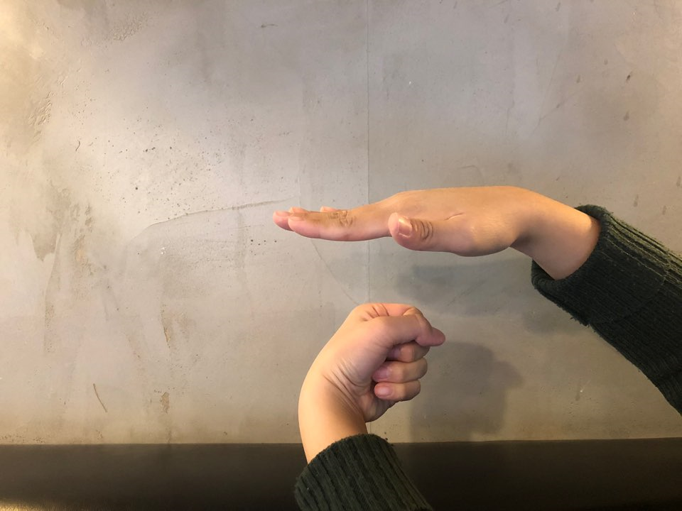

b. "사랑합니다." Convert TEXT to I love you TEXT

The application recognized the text "사랑합니다." Now, we will go through the process of converting Korean "사랑합니다." into English "I love you." We can use Google Translate API here. Using the built-in image text recognizer, we have created a code to convert to English "I love you." It doesn't really recognize all the words. We will recognize about 30 specific sign language modes and change Korean text to English text.

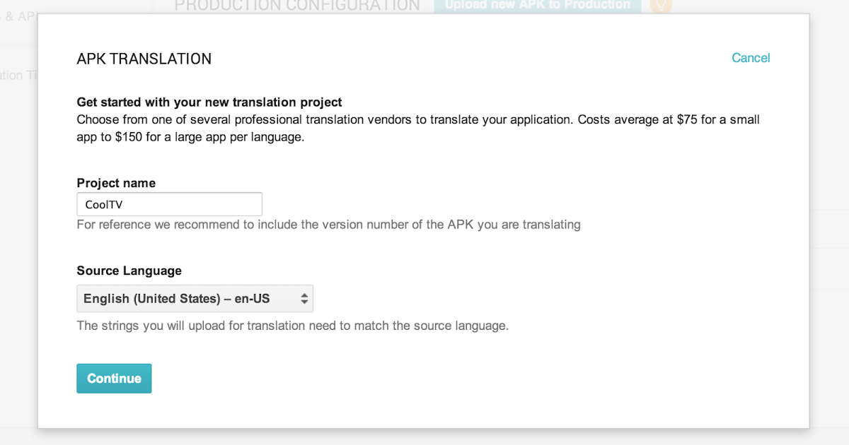

c. “I love you” text the English into sign movements

The application recognized the text "i love you". Now it's time to translate this text into English sign language. Fortunately, the English version of sign recognition tool was open source and did not have much difficulty. When you run open source on your computer, you have a camera that recognizes English sign language. By applying this, the application will recognize and store the English sign language trained for "i love you".

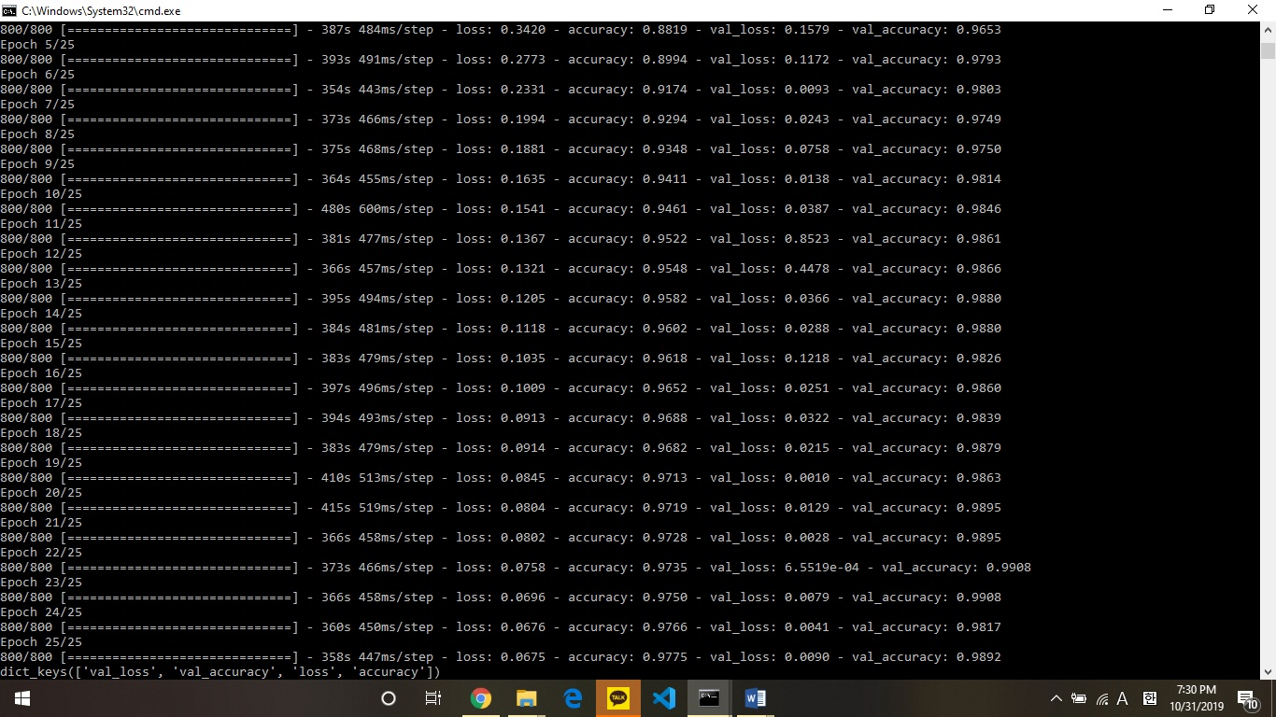

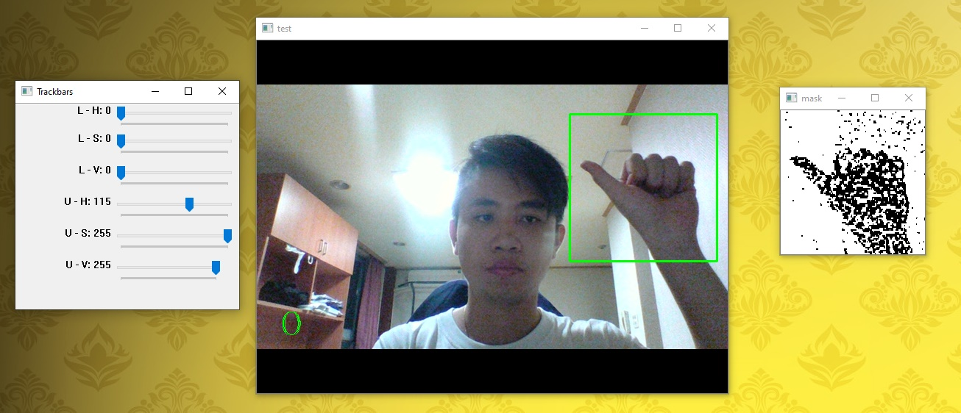

d. Output the converted action to the application

If you look at open source, if you recognize English sign language in real time, the corresponding text is printed. Our application, on the contrary, is printing text in English-language mode. The application screen will display the action that matches the "i love you". Therefore, our application will play the role of middle leg for deaf people in Korea and deaf people in the U.S. to communicate with sign language.

# ARCHITECTURE DESIGN AND IMPLEMENTATION

## Overall architecture

We have two modules consisting our application ‘HEAR, HERE’. First part is ‘Android Studio’ which is for our front end. It mainly reacts with the client(user) part. This will help us our

overall application containing several functions and designs. For our back end which mainly reacts with the database, we use Realm. Realm's mobile platform is able to build databases easily and conveniently and work with applications because it builds databases within the mobile environment. For Realm, write a java code like Android Studio. Realm\ allows you to create a model layer for apps securely, continuously, quickly and efficiently. The database stores the user's information and sign language usage information, which is linked to the application. Like this picture, these 2 modules are interacting each other for our application.

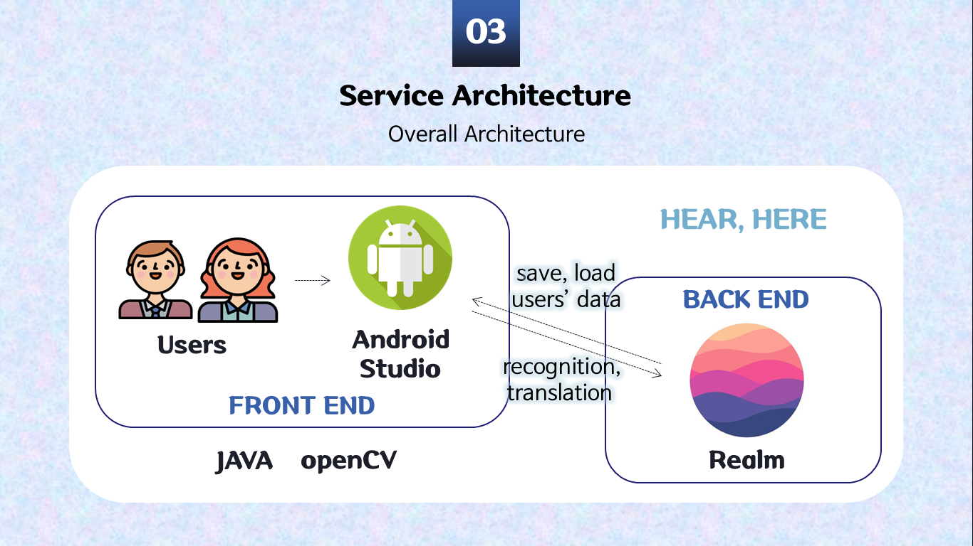

## Directory organization

This is the table which shows directory, file name and module name.

|  |  |  |
| --- | --- | --- |
| Directory | File Name | Module Name |
| javadoc/ | allclasses-frame.html    allclasses-noframe.html  constant-values.html  help-doc.html  index-all.html  index.html | Android Studio |
| javadoc/org/opencv/android/ | BaseLoaderCallback.html  CameraBridgeViewBase.CvCameraViewFrame.html  CameraBridgeViewBase.CvCameraViewListener.html  CameraBridgeViewBase.CvCameraViewListener2.html  CameraBridgeViewBase.ListItemAccessor.html  CameraBridgeViewBase.html  FpsMeter.html  InstallCallbackInterface.html  JavaCameraView.JavaCameraSizeAccessor.html  JavaCameraView.html  LoaderCallbackInterface.html  OpenCVLoader.html  Utils.html  package-frame.html  package-summary.html  package-tree.html | OpenCV |
| javadoc/org/opencv/calib3d/ | Calib3d.html  StereoBM.html  StereoMatcher.html  StereoSGBM.html  package-frame.html  package-summary.html  package-tree.html | OpenCV |
| javadoc/org/opencv/core/ | Algorithm.html  Core.MinMaxLocResult.html  Core.html  CvException.html  CvType.html  DMatch.html  KeyPoint.html  Mat.html  MatOfByte.html  MatOfDMatch.html  MatOfDouble.html  MatOfFloat.html  MatOfFloat4.html  MatOfFloat6.html  MatOfInt.html  MatOfInt4.html  MatOfKeyPoint.html  MatOfPoint.html  MatOfPoint2f.html  MatOfPoint3.html  MatOfPoint3f.html  MatOfRect.html  Point.html  Point3.html  Range.html  Rect.html  RotatedRect.html  Scalar.html  Size.html  TermCriteria.html  TickMeter.html  package-frame.html  package-summary.html  package-tree.html | OpenCV |
| javadoc/org/opencv/engine/ | package-frame.html  package-summary.html  package-tree.html | OpenCV |
| javadoc/org/opencv/features2d/ | AKAZE.html  AgastFeatureDetector.html  BFMatcher.html  BOWImgDescriptorExtractor.html  BOWKMeansTrainer.html  BOWTrainer.html  BRISK.html  DescriptorExtractor.html  DescriptorMatcher.html  FastFeatureDetector.html  Feature2D.html  FeatureDetector.html  Features2d.html  FlannBasedMatcher.html  GFTTDetector.html  KAZE.html  MSER.html  ORB.html  Params.html  package-frame.html  package-summary.html  package-tree.html | OpenCV |
| javadoc/org/opencv/imgcodecs/ | Imgcodecs.html  package-frame.html  package-summary.html  package-tree.html | OpenCV |
| javadoc/org/opencv/imgproc/ | CLAHE.html  Imgproc.html  LineSegmentDetector.html  Moments.html  Subdiv2D.html  package-frame.html  package-summary.html  package-tree.html | OpenCV |
| javadoc/org/opencv/ml/ | ANN_MLP.html  Boost.html  DTrees.html  EM.html  KNearest.html  LogisticRegression.html  Ml.html  NormalBayesClassifier.html  RTrees.html  SVM.html  SVMSGD.html  StatModel.html  TrainData.html  package-frame.html  package-summary.html  package-tree.html | OpenCV |
| javadoc/org/opencv/objdetect/ | BaseCascadeClassifier.html  CascadeClassifier.html  HOGDescriptor.html  Objdetect.html  package-frame.html  package-summary.html  package-tree.html | OpenCV |
| javadoc/org/opencv/photo/ | AlignExposures.html  photo/AlignMTB.html  CalibrateCRF.html  CalibrateDebevec.html  CalibrateRobertson.html  MergeDebevec.html  MergeExposures.html  MergeMertens.html  MergeRobertson.html  Photo.html  Tonemap.html  TonemapDrago.html  TonemapDurand.html  TonemapMantiuk.html  TonemapReinhard.html  package-frame.html  package-summary.html  package-tree.html | OpenCV |
| javadoc/org/opencv/utils/ | Converters.html  package-frame.html  package-summary.html  package-tree.html | OpenCV |
| javadoc/org/opencv/video/ | BackgroundSubtractor.html  BackgroundSubtractorKNN.html  BackgroundSubtractorMOG2.html  DenseOpticalFlow.html  DualTVL1OpticalFlow.html  FarnebackOpticalFlow.html  KalmanFilter.html  SparseOpticalFlow.html  SparsePyrLKOpticalFlow.html  Video.html  package-frame.html  package-summary.html  package-tree.html | OpenCV |
| javadoc/org/opencv/videoio/ | VideoCapture.html  VideoWriter.html  Videoio.html  package-frame.html  package-summary.html  package-tree.html | OpenCV |
| javadoc/ | overview-frame.html  overview-summary.html  overview-tree.html  package-list | Android Studio |
| javadoc/resources/ | background.gif  tab.gif  titlebar.gif  titlebar_end.gif | Android Studio |
| javadoc/ | serialized-form.html  stylesheet.css | Android Studio |

## Module 1: Android studio

1. Purpose: We use Android Studio, an integrated development environment, to develop a taxi-sharing application for the Android mobile platform. We use the Android studio provided by Google because we are developing this application for users who use the Android mobile device. Android Studio is the official integrated development environment (IDE) for Android app development, and it provides a basic layout and uses the Java language to help you develop applications easily.

2. Functionality: Android Studio is an environment that is based on all aspects of application development. We build the frontend to be displayed on the user's display through the Android studio. Android Studio also allows you to design applications using the features provided. This module also connects backend servers and DBs for application-wide development. In addition, you can develop additional functions in your application through various SDK tools provided by Android Studio.

3. Location of Source Code: howcanigetyourmind/Hear-Here-for-Hanyang-university/app

4. Class component: There are several components in the Android studio.

(1) activity_main.java: Set the spinner so that the user can select among the various items that have been set beforehand. The main class will be implemented via the intent function to move from the user's screen to the next ChatActivity.java page.

(2) activity_login.java /activity_register.java: After processing the event that goes from the login page to the member registration page, we design the membership registration. One user has information such as ID, password, e-mail, gender, and department. As a result, we have developed a membership design screen. Using firebase, we have built a database and a real app server for membership management projects. After the Log-in function, the function to switch the activity to the main screen is implemented.

(3) UserRegister.php / userValidate.php: UserRequest actually implements the login function after this part of UserValidation has set the PHP web server for login. Android attempts to log in to the web server and displays a message that the account information is not available if the IDs do not match. On the other hand, if the IDs match, you can go to the main screen.

## Module 2: Realm

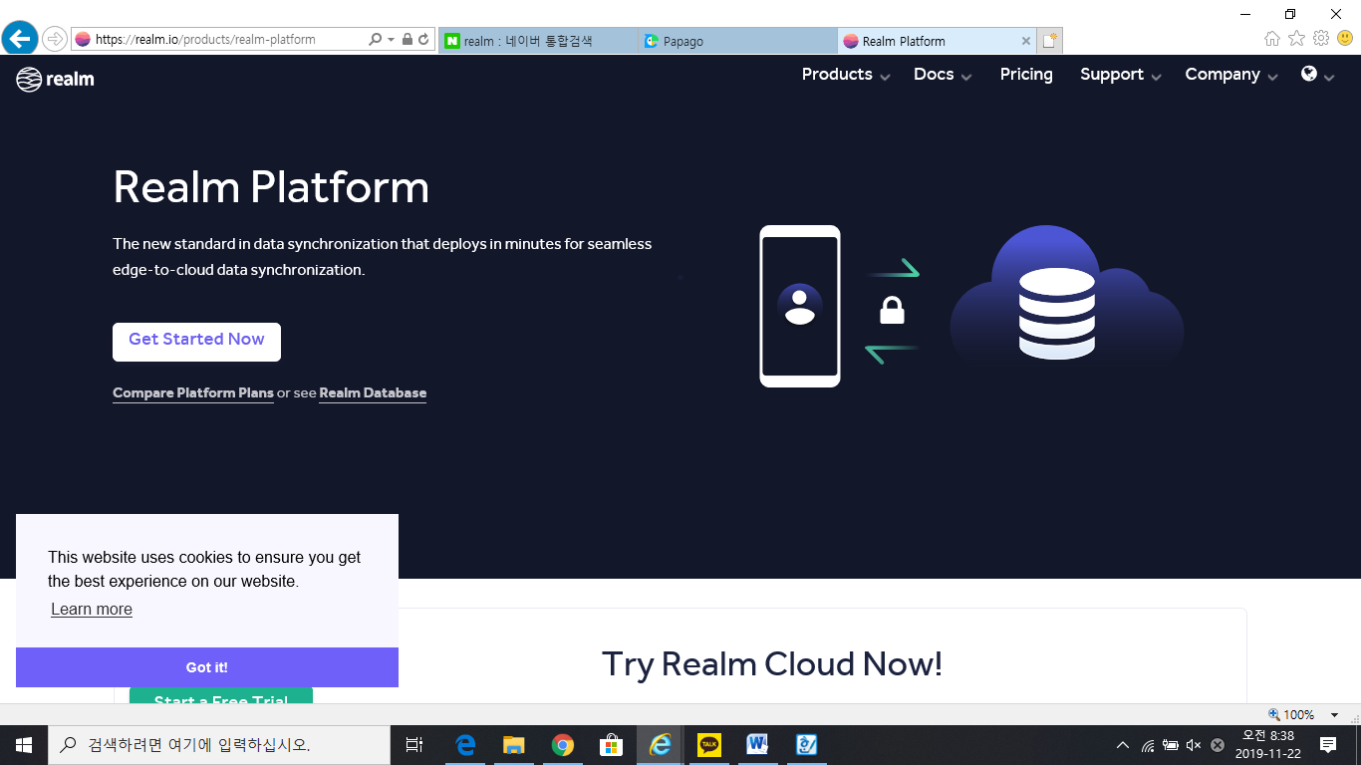

1. Purpose: We used Realm to provide the database infrastructure. Realm is a mobile and web application development platform.

2. Functionality: The information of the user who joined the Realm and login membership page is stored in the Realm certificate file. We can see the user's ID and password information through the Realm console, and also delete the user from the console.

3. Location of Source code: Realm is the on-line database, so it does not need any location.

4. Class component: There are several components in Realm.

(1) Real-time database: Realm provides a real-time database and backend as a service. The service provides application developers an API that allows application data to be synchronized across clients and stored on code location.

## OpenCV



OpenCV (Open Source Computer Vision Library) is an open source computer vision and machine learning software library. OpenCV was built to provide a common infrastructure for computer vision applications and to accelerate the use of machine perception in the commercial products. Being a BSD-licensed product, OpenCV makes it easy for businesses to utilize and modify the code.

The library has more than 2500 optimized algorithms, which includes a comprehensive set of both classic and state-of-the-art computer vision and machine learning algorithms. These algorithms can be used to detect and recognize faces, identify objects, classify human actions in videos, track camera movements, track moving objects, extract 3D models of objects, produce 3D point clouds from stereo cameras, stitch images together to produce a high resolution image of an entire scene, find similar images from an image database, remove red eyes from images taken using flash, follow eye movements, recognize scenery and establish markers to overlay it with augmented reality, etc. OpenCV has more than 47 thousand people of user community and estimated number of downloads exceeding [18 million](https://sourceforge.net/projects/opencvlibrary/files/stats/timeline?dates=2001-09-20+to+2019-01-30). The library is used extensively in companies, research groups and by governmental bodies.

Opencv supports several built-in functions.

(1) nChannels: It indicates the number of channels per pixel of the image. It is 1 ~ 4 value, the number of channels of black and white image is 1, the number of channels of RGB color image is 3 and RGB color sequence is as follows.

- b0 g0 r0 b1 g1 r1 b2 g2 r2 b3 g3 r3

(2) origin: indicates the origin of the image. 0 means top-left origin and 1 means bottom-left origin.

(3) depth: indicates the number of bits used to store the image data. Depth, like the data type in computer languages, indicates how many bits to represent the data, for example in C, where integers have int and long types and real types have floats and doubles.

(4) width: The horizontal size of the image. The unit is pixel.

(5) height: indicates the vertical size of the image. The unit is pixel.

(6) widthStep: The horizontal size in the image and the unit is byte. widthStep = width * nChannels. In an 8-bit 1-channel image, if the image has a width of 100 pixels, it is 100 bytes with widthStep = 100 * 1;

(7) imageSize: It indicates the size of image and the unit is byte. imageSize = width * height * nChannels. For a black and white image with 256 pixels wide and 256 pixels high, imageSize is 65,536 bytes (256 pixels * 256 pixels * 1 channel = 65,536 bytes) and for color images with 256 pixels wide and 256 pixels, imageSize is 196,608 bytes (256 pixels * 256 pixels). 3 channels = 196,608 bytes).

(8) iscolor : Indicates the color of the loaded image.If iscolor> 0, it converts to 3 channel color image and loads.If iscolor = 0, it converts to black and white image and loads.If iscolor <0, the original image is loaded. That is, the original image is loaded with the three-channel color image as the color image and the monochrome image as the monochrome image. For example, the following loads a Lena color image into a memory as it is.

1. Purpose: In our structure, opencv is an important module, of course. In particular, opencv plays a very important role in recognizing sign language. Various methods have been proposed when recognizing hand gestures and converting them again. In the next usercase and final test bones we will focus on opencv. We determined that no library is as good as opencv for recognizing images.

2. Functionality: This library has 5 important functions

- RGB to HSV conversion

- Dilation and Erosion

- Blurring

- Find Contours

- Forming Convex Hulls

3. Location of Source Code: javadoc/org/opencv

4. Class component: There are several components in OpenCV.

(1) Skin Color Segmentation: We use HSV to detect the threshold value of hue, saturation, and brightness. Then the HSV image will be converted into a binary image where the desired pixels were given a value of 1(White) and the background pixel was given a value 0(black)

(2) Background Subtraction: We use this image processing technique to distinguish moving fingertips from the background.

(3) Final Hand Segmentation Technique: Despite the demerits of skin color segmentation (such as susceptibility to varying light conditions and background noises) this method was chosen over background subtractions because background subtraction needs a static background for successful implementation.

# USE CASES

## Installation

You can search our applications in the Google Play Store. For iOS, we have to study additional swift language and could not implement it. It would be nice if the deaf or interested parties could install the Anglo-American sign language to Korean sign language. Our app will be installed on your phone with a few clicks.

## Turn on the application

If you want to turn on the HEAR, HERE application, just click the icon to run it. You will see various interfaces. You can press the Exit button, or you can press the Back button.

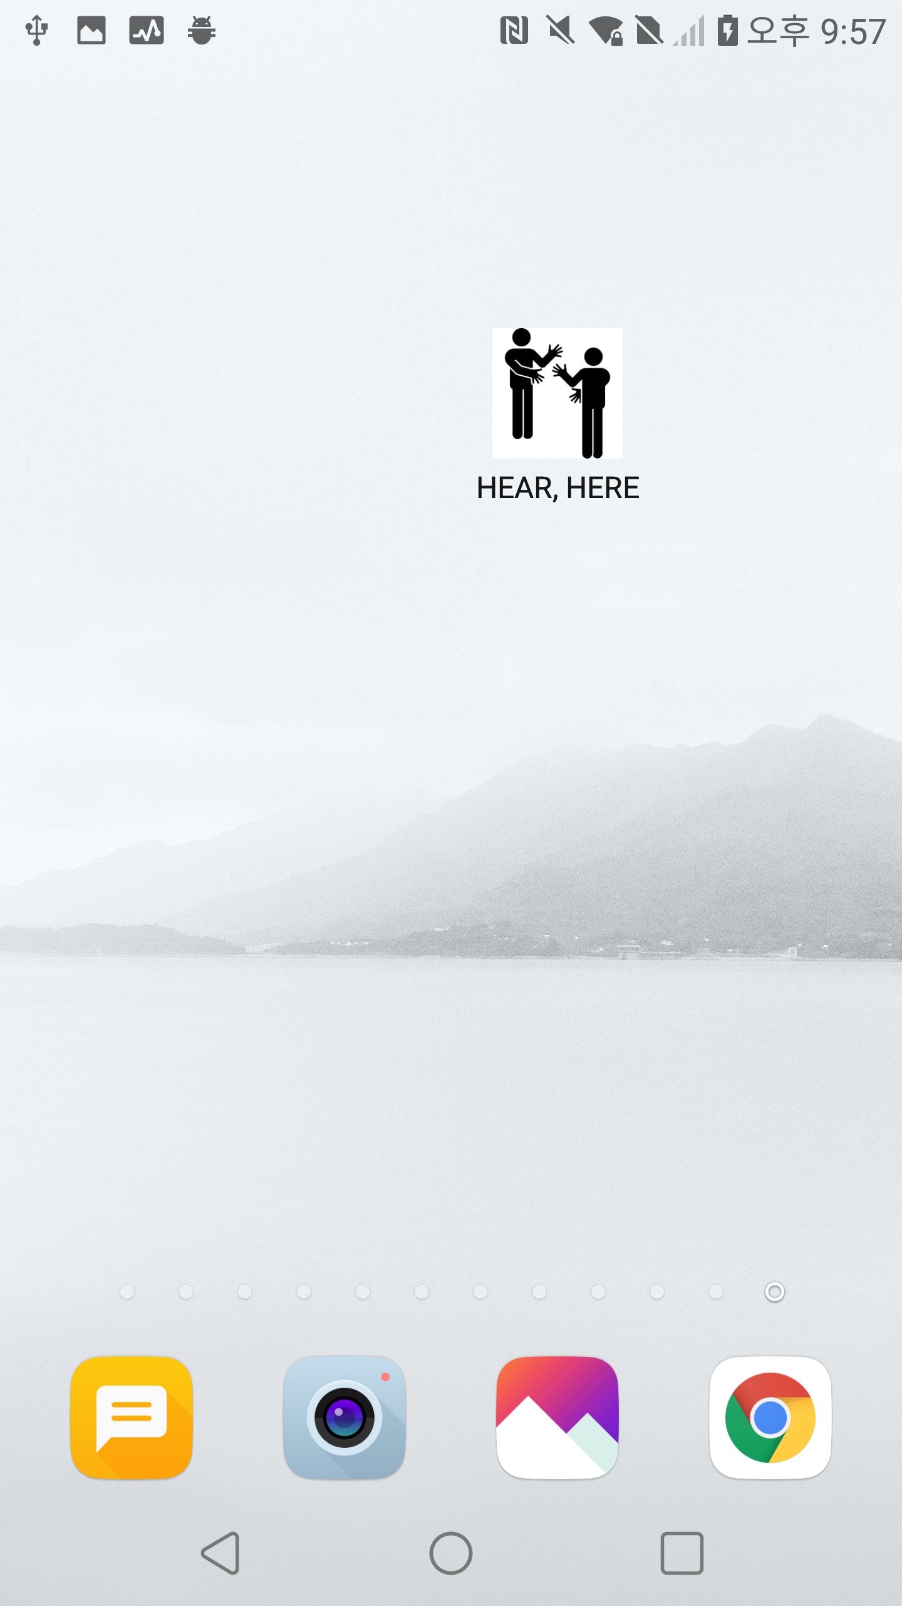

## Main Page

The main page is the core of the application. First of all, You can see Email and Password on the main page. This is for sign in and is not necessary to use the translation function.

If you click on the logo icon for the application, you will go to the translation window without sign in.

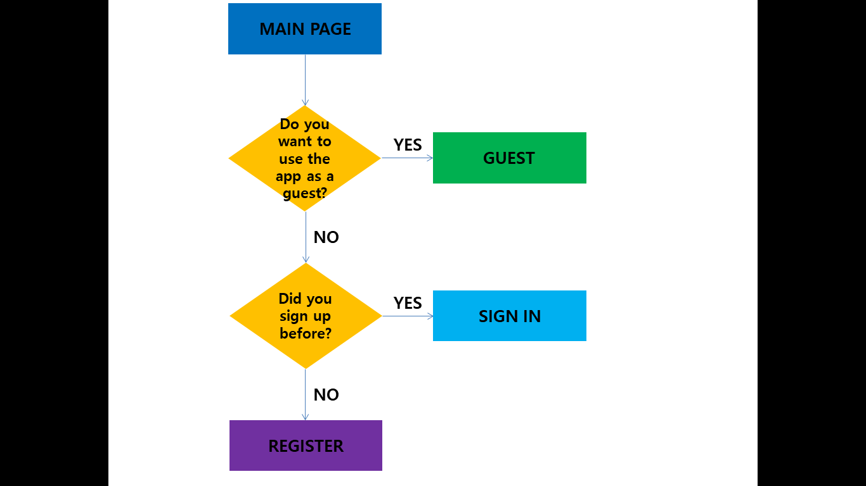

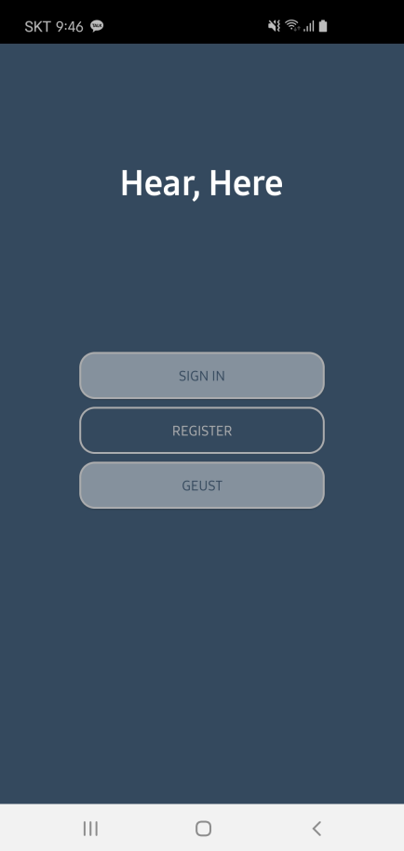

Then the camera will run, and the application will be ready to recognize your hand. On the screen, there are boundaries for recognizing your hands, and when you show your hands on the camera, you can see many lines for recognition.

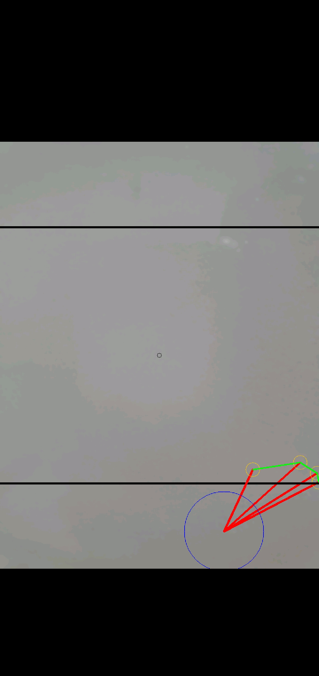

## Sign-Up

a. Create

- Press the ‘CREATE’ button if you want to join

b. You must complete your personal information.

- Email

- Password

- Name

- Age

- Nationality

- Gender

- Deaf or not

c. Please enter all information correctly. That way, you will be able to sign up. The reason for asking if you are deaf is to investigate the proportion of deaf people and to produce applications more effectively in the future.

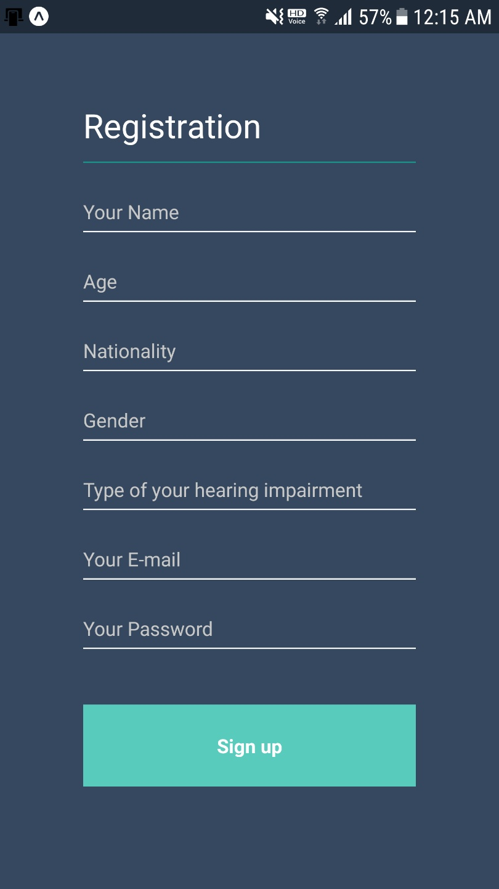

## Log-in

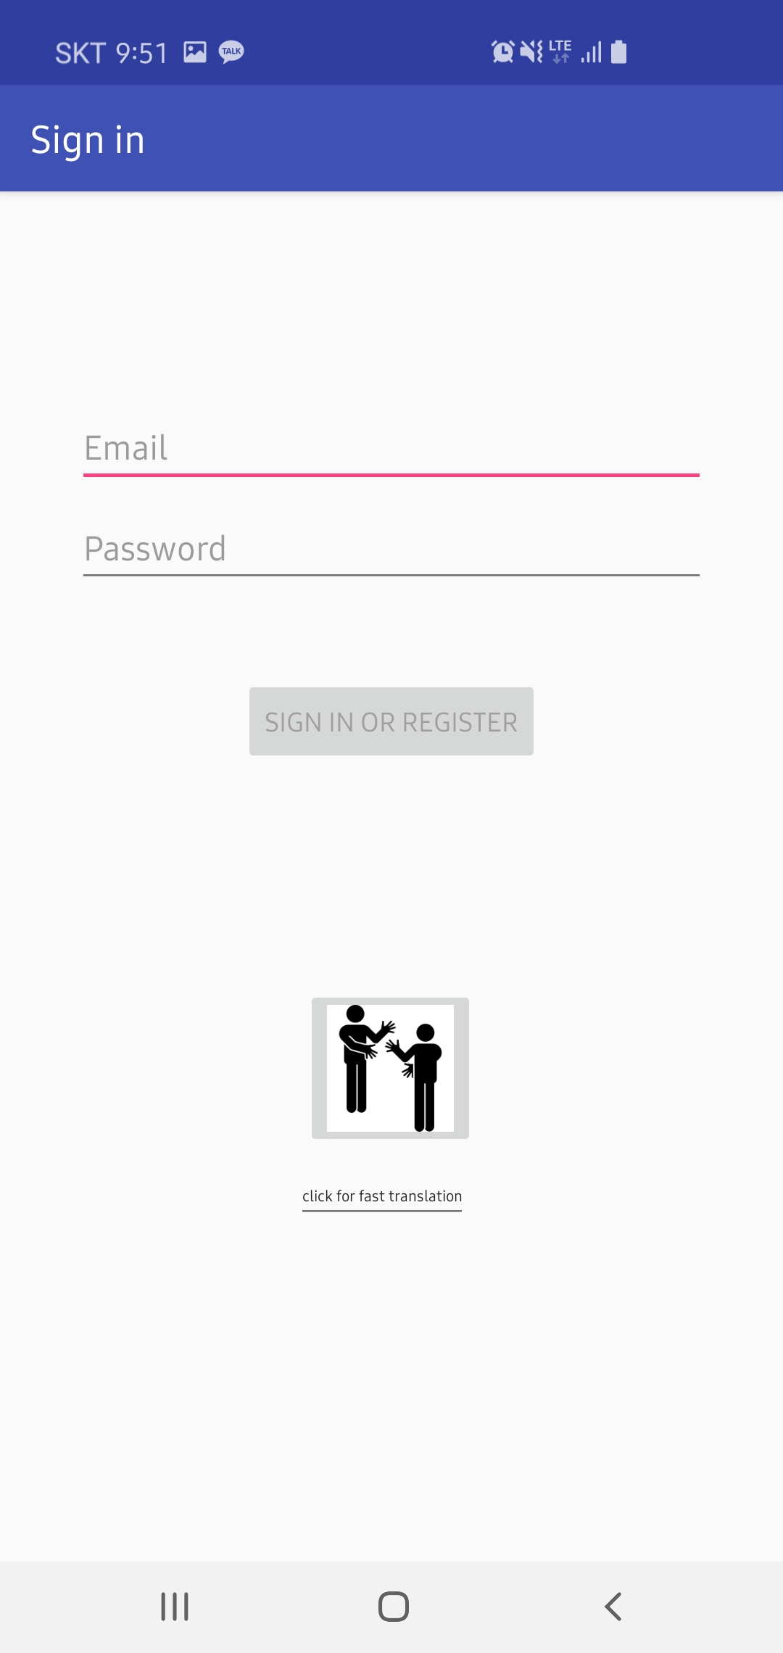

a. Email

This is the first screen of our application. When the users login, they must enter their Email.

b. Password

The password is a combination of English and numbers and can be up to 10 characters long.

## Camera

Cameras are the most important function in our applications. Because we need to recognize sign language.

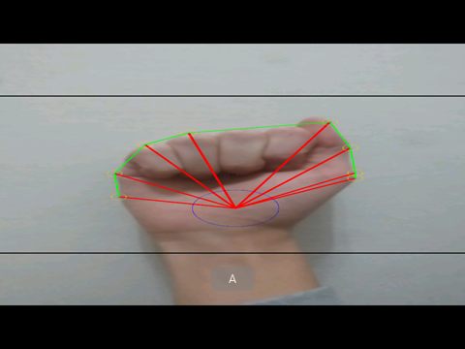

For example, when a user signs an alphabet A, the toasts are briefly shown and disappear from the screen.

Also, we will convert A into ㄱ.

(B = ㄴ, C = ㄷ, D = ㄹ, E = ㅁ, F = ㅂ, G = ㅅ …)

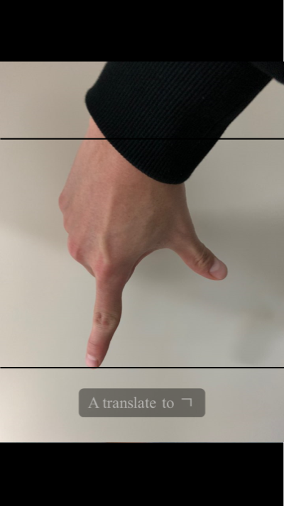

## After one recognition

After one recognition, the sentence "Do you want to continue?" appears.

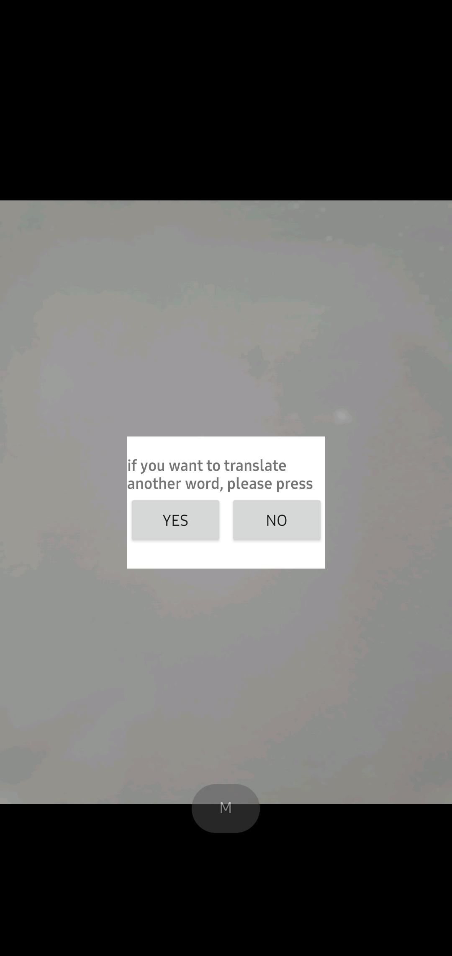

- If the user presses the ‘YES’ button, it continues to be recognized.

- If the user presses the ‘NO’ button, it exits and moves to the main page.

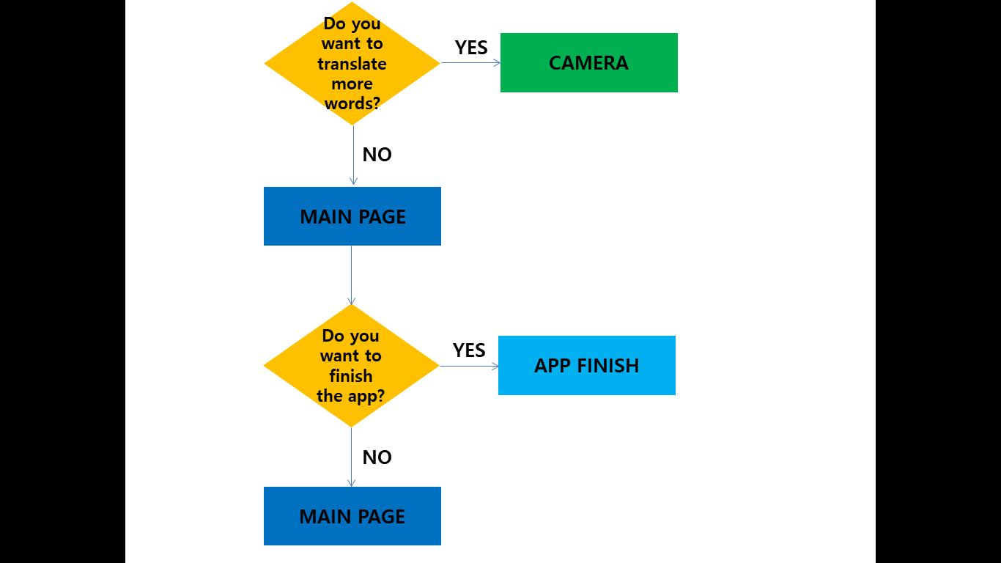

## Turn off the application

- User can make an evaluation of the app with a simple star score before the service.

- After the users finish the recognition, if the users click the ‘Exit’ button, “"Do you really want to finish?" appears.

- If the user press the exit button once more, the user will go to the Home screen.

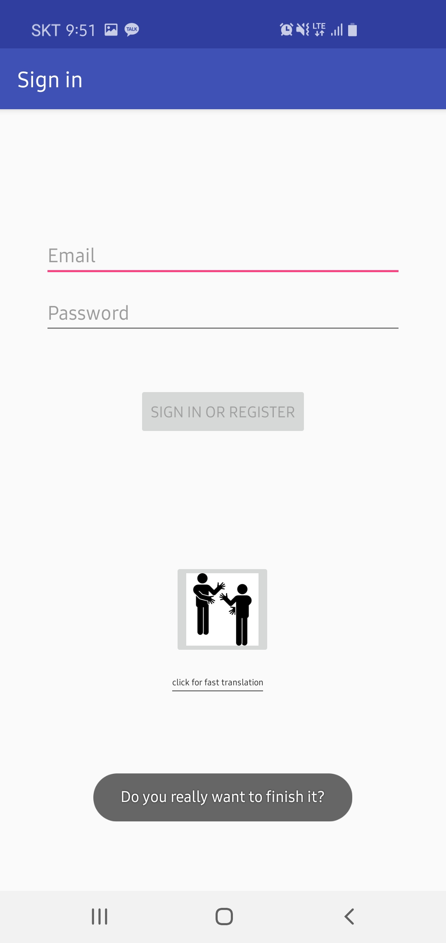

# INSTALLATION GUIDE

## Introduction

This part is for our application users and we will give some information about how to use it. Our first goal in this application is to users match fast because of their comfort. Therefore, this user guide is very simple and the users can follow easily.

## Installation procedure

Step 1. Choosing entering method

The user first has to decide whether to use our application as guest or as a member. If users are entering Guest, user can press the 'guest' button and then execute the interpreter. If users want to be a Member, user can sign up using the 'register' button.

Step 2. Sign up

For using our application as a member, users should sign up. Users should input E-mail and password. After that, they should click the ‘REGISTER’ button.

Step 3. Log-in

If the E-mail is not on the database already so the registration is successful, then the users can Log-in.

Step 4. Translator

When the camera is turned on, the user performs the English sign language he or she wants to translate. Our application recognizes this and shows the translation of the Korean sign language on the screen.

If users want to translate sign language one more time, select 'Yes' when asked if user would like to translate further. Users can then perform the sign language action user want to translate as user did in the beginning.

If users want to stop interpreting, users can choose 'no' to ask questions from the same application and return to the main screen.

Step 5. Finish

If users press Back on the main screen, the question 'Do you really want to exit the application?' will appear. At this point, if users press back one more time, the application will be terminated.

# DISCUSSION

In the last three months of software engineering process is the importance of communication among team members who are the practicalities of implementation, software and told you everything.Valuable time that can be experienced. However, applications than ever after to produce the ‘hear, here’ sign language interpreter is also true that I had a lot of trouble. Above all, to enable the accurate recognition of sign movements, it was just hard. Our team is the first time as Web cams to enable recognition of sign language to using our applications using the open-source. However, this is the Korean language server problem that must be connected to create a data set. This is too long and difficult time. In addition, the success, application environments to build the system again in the process was too hard.

So our team recognize sign language as its own app using the Android source code that can be found. Also, many just because of his problems this code is not easy to use. Analyzing the source code one by one, looking for any problems and modifying the code in several ways to make it work. At this point it deeply about learning about because it was essential to understand about opencv. After the recognition of accurate sign language movements was made possible, the Korean sign language was directly inputted to make it function as a sign language interpreter. And to completing the form of the application by adding ux by many, too. And in order to create a single piece of software modules and systems, and many study is needed. This process is not an easy job, but the path through the steps, grow before they could tell us. In addition, teamwork is very important because development activities, can know the importance of the team.

Well aware that many of our applications are lacking. I want to develop further the app to study our constantly in the future. 1. We will be able to recognize Korean sign language movements, so that they can be translated from Korean sign language to English sign language. 2. Recognizing motion by video, translation results will also be printed by video. 3. We will distribute our applications on the market so that they can actually be used by users. We will have a lot of difficulties in doing these activities, but I really want to solve them and show them that we are getting better.

<Github repository>

<https://github.com/howcanigetyourmind/Hear-Here-for-Hanyang-universty->

<Demo link>

<https://www.youtube.com/watch?v=97ep3BYQpzo&feature=youtu.be>

1.